POSTMAN DOCUMENTATION

Recipe API A simple REST API built using Node.js, Express, MongoDB, and Mongoose to manage recipes.
🚀 Features Create Recipe Get All Recipes Get Recipe By ID Update Recipe By ID Delete Recipe By ID 🛠️ Tech Stack Node.js Express.js MongoDB Atlas Mongoose dotenv Nodemon 📂 Project Structure mongose/ │── Controllers/ │ └── recipe.controller.js │ │── Database/ │ └── config.js │ │── Models/ │ └── recipe.model.js │ │── Routes/ │ └── recipe.routes.js │ │── .env │── index.js │── package.json
http://localhost:4000
📌 API Endpoints
🔹 Create Recipe POST /recipes
🔹 Get All Recipes GET /recipes
🔹 Get Recipe By ID GET /recipes/:id
🔹 Update Recipe PUT /recipes/:id
🔹 Delete Recipe DELETE /recipes/:id
🧾 Sample JSON
{
"title": "Chicken Biryani", "ingredient": "Chicken, Rice, Onion, Tomato, Spices",
"instructions": "Cook chicken. Add rice. Mix spices. Cook well.",
"cookingTime": "45 minutes"
}

🔹 Get Recipe By ID GET /recipes/:id
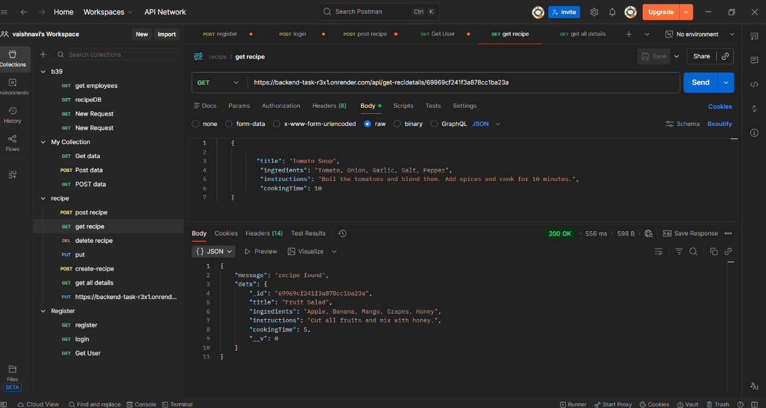

🔹 Update Recipe PUT /recipes/:id

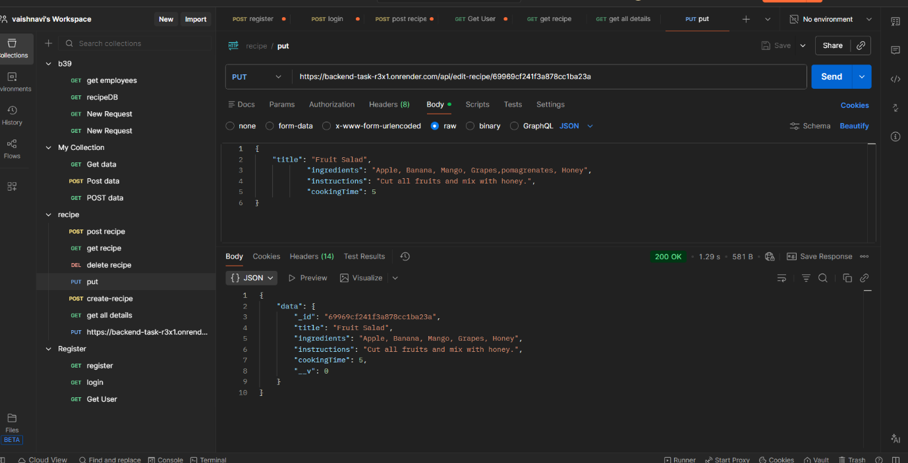

🔹 Get All Recipes GET /recipes
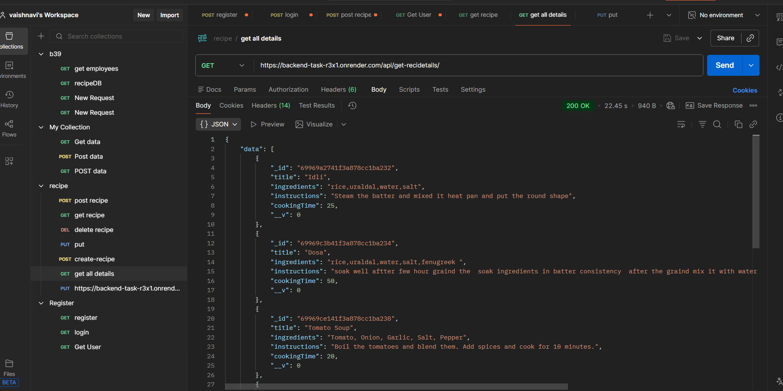

🔹 Delete Recipe DELETE /recipes/:id

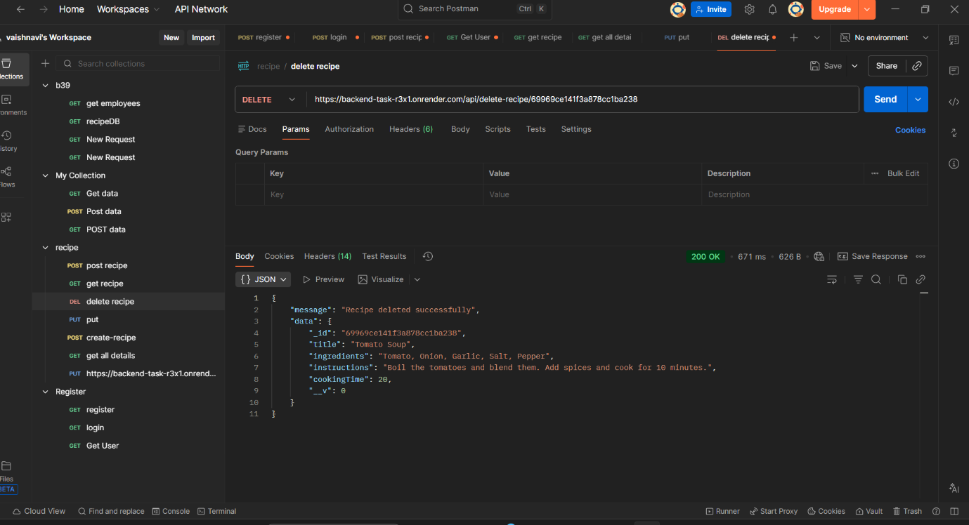

Post Recipe /recipes

